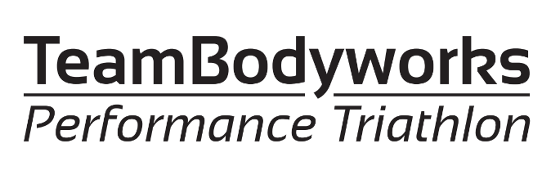

Online Training Packages
Disclaimer
Before participating in any of the below plans, please read the information below;
- You should consult a medical professional before commencing any new exercise program.
- If you have any underlying medical conditions, you should consult with your GP or healthcare professional to confirm that the program is appropriate for your needs.
- If you are fit and well or have been given approval to take part in training for triathlon by your GP, please take responsibility regarding your health and always STOP activity if a new health issue occurs or an existing condition worsens.
- As with any form of exercise, the disciplines of Triathlon training do have elements of risk of injury and you should ensure appropriate steps are taken to lessen these such as wearing appropriate clothing and checking equipment is in good condition.
- Swimming in open water presents added risks and you should make sure you have appropriate clothing for the conditions and your ability. These may include wetsuit, life buoy, swim hats, boots and appropriate warm clothing post swim. You should also swim with a buddy and in lifeguarded swim zones at all times.
- Team Bodyworks has provided the below self-led plans to support you in your training and you should be at a reasonable level of fitness and competent in each discipline before taking part.
- By signing up to a Team Bodyworks plan you agree to do this at your own risk and confirm you have read the above.

TriBourne Training Plans
We are pleased to announce that Team Bodyworks are providing training plans to all 2023 TriBourne competitors to help you prepare for your event.
Please note Team Bodyworks are providing these plans for free for 2023 entrants to Tribourne Events, but ask in return that you make a Just Giving donation to one of two local charities:
- Eastbourne Voluntary Lifeguards was founded in 1948 to deliver training to members of our community that could potentially save their own lives and the lives of others. They also support local events through providing water safety and first aid cover, alongside sharing drowning prevention messages and will be supporting TriBourne Events.
- St. Wilfrid’s Hospice is a local charity providing skilled and compassionate care and treatment for all patients and their families with complex needs as they near the end of life. St Wilfrid’s Hospice serves a population of around 230,000 living in Eastbourne, Polegate, Pevensey, Seaford, Hailsham, Heathfield, Uckfield and everywhere in between. For more information, visit www.stwhospice.org

These programs will be delivered via Training Peaks and have been developed specifically for the TriBourne events, giving you a guide on the appropriate training required to complete and enjoy your event, taking into consideration the sea swim and terrain on the bike and run.
Supplying you with detailed bike, run and swim sessions for both pool and open water, you will also gain access to three hours of Team Bodyworks live coached online sessions per week covering strength, conditioning and indoor cycle/turbo training:
- Strength and Conditioning - Tuesdays 6:30am to 7:30am on Zoom
- Turbo - Tuesdays 6pm to 7pm on Zoom
- Core Stability, Mobility and Relaxation - Fridays 6:30am to 7:30am on Zoom
These have all been designed to take you right up to race day!
If these appeal to you, please contact Steve (spclark79@hotmail.com).
- Super Sprint - A 6-week plan aimed at novices.
- Sprint Distance and Olympic Distance - A 6-week plan ensuring you enjoy your day at the Eastbourne Sprint or Olympic Distance triathlons.
- Middle Distance - A 10-week training plan designed for athletes who have entered IronBourne Middle Distance triathlon and have built a reasonable level of fitness.

PLAN 4 - Open Water Swim Sessions 1:1 £50 : 2:1 £65 : 3:1 £80
These will be 60min sessions in the Sea at Eastbourne and delivered 1:1, 2:1 or 3:1 with one of the Team Bodyworks Coaching team and will cover
- sighting
- getting in and out of your wetsuit
- course familiarization for your event
- reading the currents
- understanding tides
- entering and exiting water safely

Athletes should be able to swim 200m in a pool non-stop and unaided to join these sessions
For further information or to book an appointment please contact Steve (spclark79@hotmail.com)

To pay for Open Water Swim Sessions, please use below Bank Details
Please enter your name as a reference on the transfer.
Bank: Lloyds Bank Plc, 104 Terminus Road, Eastbourne
Sort code: 30-92-86
Account name: Bodyworks XTC Ltd
Account number: 00100318
Ref: Athletes name PLAN ‘Number’

